

**SEMESTER TWO 2019**

**Classification Science Test:**

**ANSWER BOOKLET**

**NAME: ANSWERS**

**FORM:** **DATE:**

Multiple Choice Short Answer Total

**/31**

**/10**

**/41**

**SECTION ONE:** Multiple choice answers

Cross (X) through the correct answer.

|  |  |  |  |  |
| --- | --- | --- | --- | --- |
| **1** | a | b | XXX | d |
| **2** | XXX | b | c | d |
| **3** | a | XXX | c | d |
| **4** | a | b | c | XXX |
| **5** | XXX | b | c | d |
| **6** | a | b | c | XXX |
| **7** | a | b | c | XXX |
| **8** | a | b | c | XXX |
| **9** | a | b | c | XXX |
| **10** | a | XXX | c | d |

**Part B: Short Answer Questions (31 marks)**

**Answer in the spaces provided.**

1. Biologists use factors or criteria to determine whether something is living or non-living.

a) Using MR N GREWW, write down the 8 criteria that an object must satisfy to be considered living. (4 marks) **0.5 mark each**

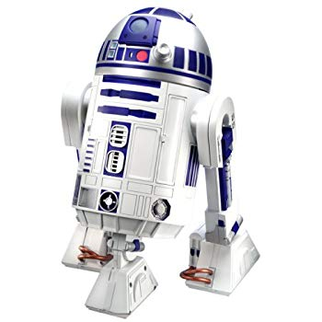  
M**ovement**____________________________________________  
  
R**espond to change**____________________________________________________________  
  
N**utrients**_________________________________________________________  
  
G**row**___________________________________________________________________  
  
R**eproduce**________________________________________________________________________  
  
E**xchange gases**_________________________________________________________________  
  
W**ater**____________________________________________________________________________  
  
W**aste**____________________________________________________________________________   
  
  
  
b) This is a picture of a robot.   
 Sammy thinks robots are a living thing.  
Bobby thinks the robots are a non-living thing.  
  
  
  
  
  
  
  
  
  
i) Who is correct? Bobby or Sammy? (1 mark)  
  
**Bobby**  
  
ii) Using MR N GREW, explain your answer (2 marks)  
  
**Using one or more characteristics of MR N GREWW (1 mark)  
State how the robot does not fit it (1 mark)**

12. To classify things, objects need to be compared to each other by looking at their similarities and differences. Below are two pictures. (2 marks)

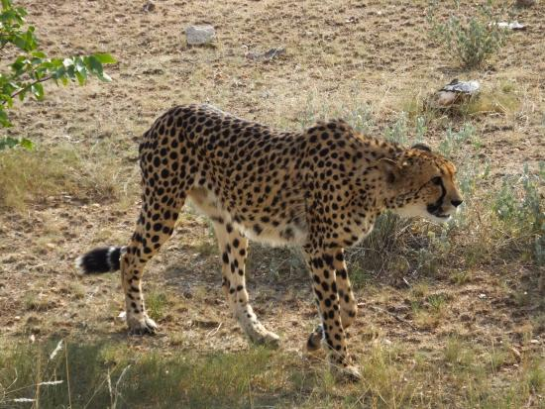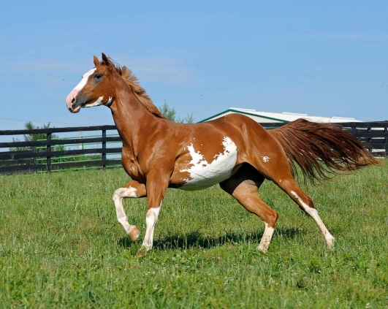

1. Write down 2 similarities between the animals above  
     
   **0.5 mark for each suitable similarities**
2. Write down 2 differences between the animals above  
     
   **0.5 mark for each suitable differences**

13. We classify many things in everyday life, not just living things. (2 marks)  
  
a) State two reasons of using classifications  
 **0.5 mark for each suitable reason**  
  
b) Can you name two places in everyday life that classification is used  
  
 **0.5 mark for each suitable uses**

14. Use the key below to classify the animals pictured here. (4 marks)

**KEY**

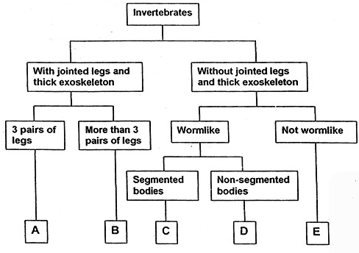

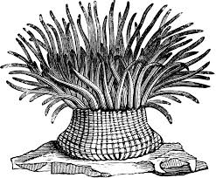**ANIMALS**

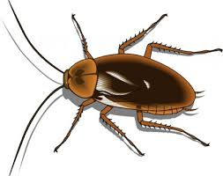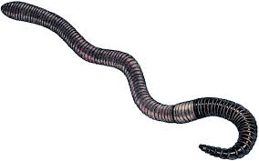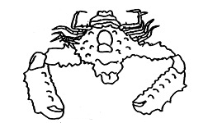

1 2 3 4

|  |  |
| --- | --- |
| **ANIMAL** | **GROUP (A,B,C,D or E)** |
| **1** | B |
| **2** | C |
| **3** | A |
| **4** | E |

15. Using the 3 creatures below, design a Dichotomous key (minimum of 3 steps)

to help identify them based on 2 or more specific characteristics. (3marks)

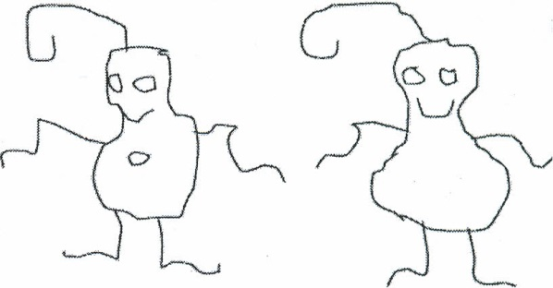

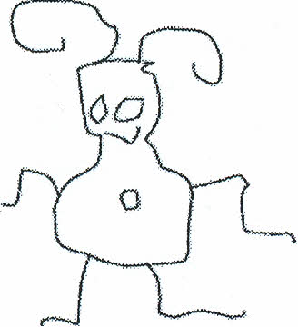

GLIP

BIP

GLOP

1 mark for appropriate characteristics,

1 mark for correctly drawn

1 mark for individuals isolated at bottom of key

16. Use the key to identify the name of each alien below. (5 marks)

**Alien Dichotomous Key**

1. A. Does the alien have feet?…………………………..Go to statement 2

B. Does the alien have no feet?……………………….Go to statement 7

2. A. Does the alien have socks?………………………..Go to statement 3

B. Does the alien have no socks?…………………….Go to statement 5

3. A. Does the alien have antennae?…………………….Go to statement 4

B. Does the alien have no antennae?…………………It is alien K

4. A. Does the alien have two eyes?…………………….It is alien R

B. Does the alien have less than two eyes?……………..It is alien M

5. A. Does the alien have toes?………………………….Go to statement 6

B. Does the alien have no toes?………………………It is alien T

6. A. Does the alien have long hair?…………………….It is alien Z

B. Does the alien have no long hair?………………….It is alien N

7. A. Does the alien have eyes on stalks?……………….Go to statement 8

B. Does the alien have eyes not on stalks?……………Go to statement 9

8. A. Does the alien have a nose?……………………….It is alien X

B. Does the alien have no nose?………………………It is alien Y

9. A. Does the alien have arms?…………………………It is alien V

B. Does the alien have no arms……………………….It is alien W

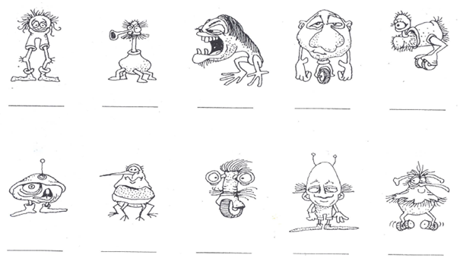

**0.5 marks each**

W

R

Y

N

M

X

V

Z

T

K

17. Classify the following living things **0.5 marks each correct thing**  
  
a) Dog (1.5 marks)

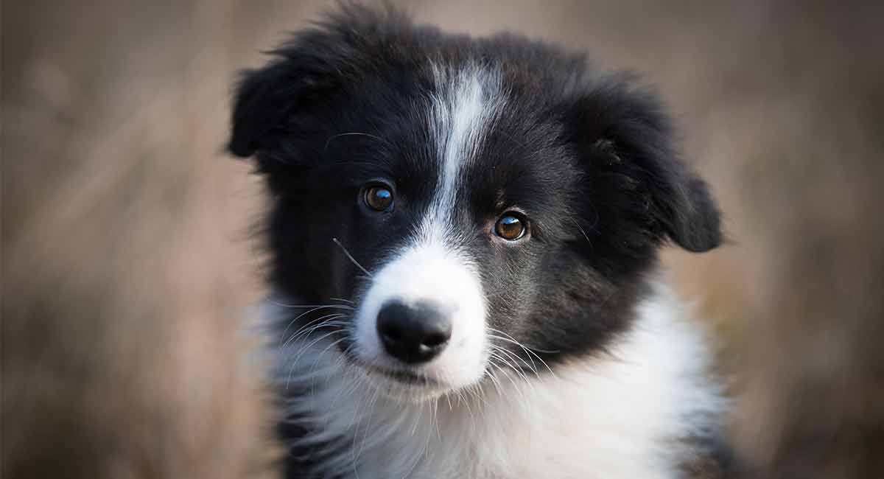

Kingdom **- Animalia**  
  
_____________________________  
  
Phylum **- Chordata**  
  
_____________________________  
  
Class- **Mammal**  
  
_____________________________

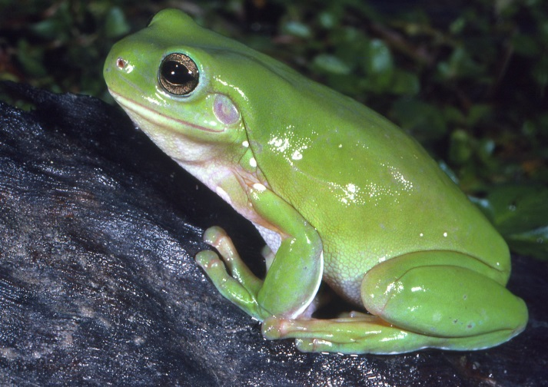b) Frog (1.5 marks)

Kingdom**- Animalia**  
  
_____________________________  
  
Phylum**- Chordata**  
  
_____________________________  
  
Class - **Amphibian**  
  
_____________________________

c) Turtle (1.5 marks)

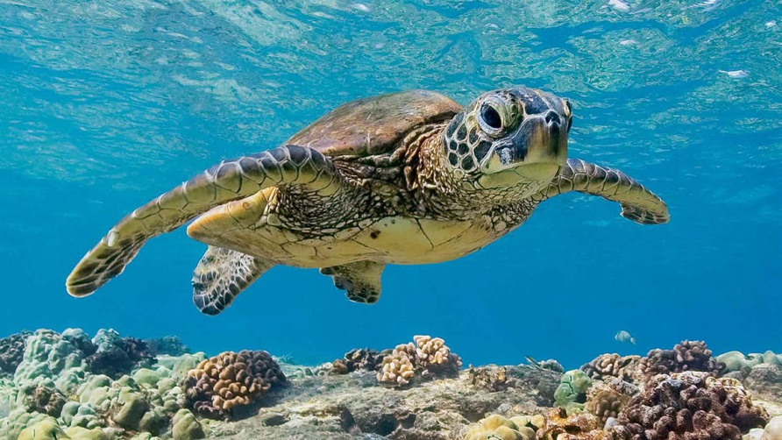

Kingdom**- Animalia**  
  
___________________________  
  
Phylum**- Chordata**  
  
___________________________  
  
Class - **Reptile**  
  
___________________________

d) Snail (1 mark)

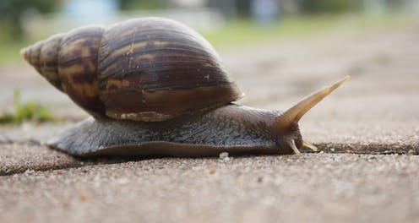   
Kingdom**- Animalia**  
  
___________________________  
  
Phylum- **Mollusc**  
  
___________________________

e) Toadstool (0.5 mark)  
  
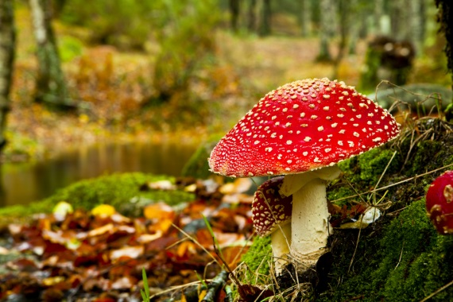Kingdom - **Fungi**  
  
___________________________

f) Bacteria (0.5 marks)

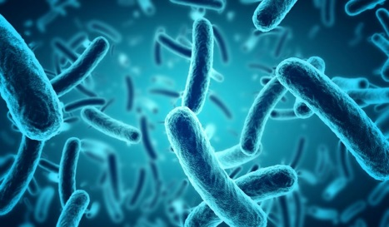

Kingdom - **Monera**  
___________________________

18. A crocodile is a living thing. (1.5 marks)

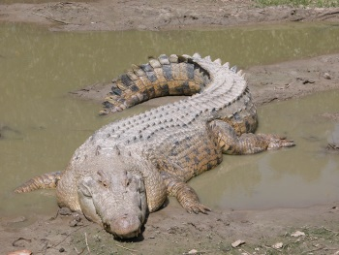Can you describe the features of a crocodile why they are classified as below?

Kingdom: Animalia  
Phylum: Chordata

Class: Reptile  
  
**0.5 mark for each part**

**Eg. Reptile – coldblooded  
Chordata – Has backbone  
Animalia – Multi-celluar that consumes food**